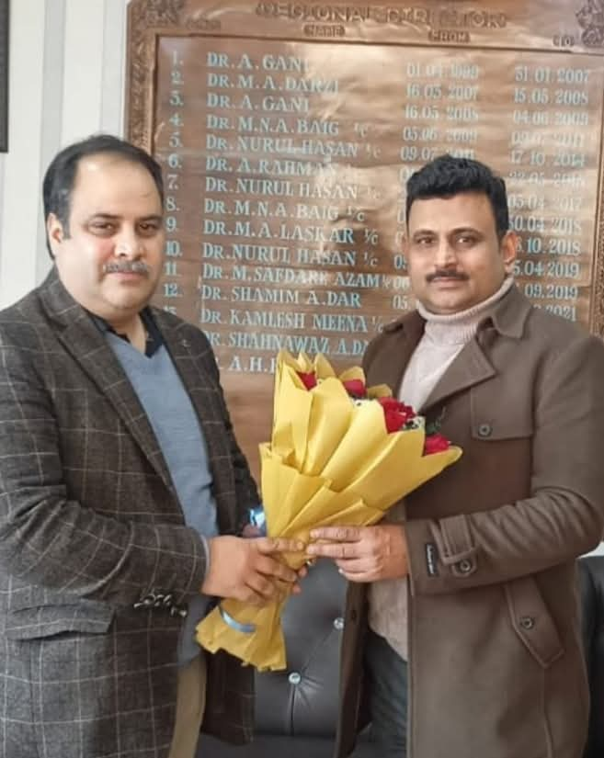Today, Sh. Ashaq Hussain Dar Director InCharge NIELIT J&K(Deemed to be University) visited IGNOU Regional Centre Srinagar to have a courtesy meeting with Dr. A.H. Rizvi Regional Director IGNOU Srinagar. Duo discussed collaboration between two institutions for providing quality education to IGNOU learners, job employability and induction of IGNOU Learners in various new government schemes and programmes run by NIELIT.

Shri Ashaq highlighted several online and offline skill development programs, which can be beneficial for IGNOU students, particularly in the areas of IT, electronics, and computer science. These programs include certifications in areas such as digital literacy, cyber security, block chain, drone technology and software development, which would complement the academic programmes offered by IGNOU. He also shared information about its paid internship and placement schemes, where IGNOU students can access various industry partnerships and placement opportunities. This initiative will bridge the gap between academic learning and real-world industry requirements.

The meeting also touched upon NIELIT's support for entrepreneurship among IGNOU students as NIELIT offers mentorship and training programs for students interested in starting their own businesses in the IT and electronics sector. These programs are designed to help students develop the necessary skills to launch startups. It was also proposed to collaborate with IGNOU on research projects, particularly in the field of emerging technologies such as artificial intelligence (AI), machine learning, block chain, the Internet of Things (IoT) and more. The collaboration would aim to foster innovation and research among students.

Dr. Rizvi invited director NIELIT to be one of the key member of the placement cell of Regional Centre for giving more impetus to the placement drives organised by IGNOU. Shri Ashaq also invited IGNOU students from computer science stream for facilitating them in the placement drives organised by NIELIT.

The meeting concluded with both parties agreeing to explore these opportunities further, with an emphasis on developing a collaborative framework that benefits IGNOU students through access to NIELIT’s schemes.