[](http://www.nielit.gov.in/)

राष्ट्रीयइलेक्ट्रॉनिकीएवंसूचनाप्रौद्योगिकीसंस्थान

**National Institute of Electronics & Information Technology (Formerly CEDT),Aurangabad**

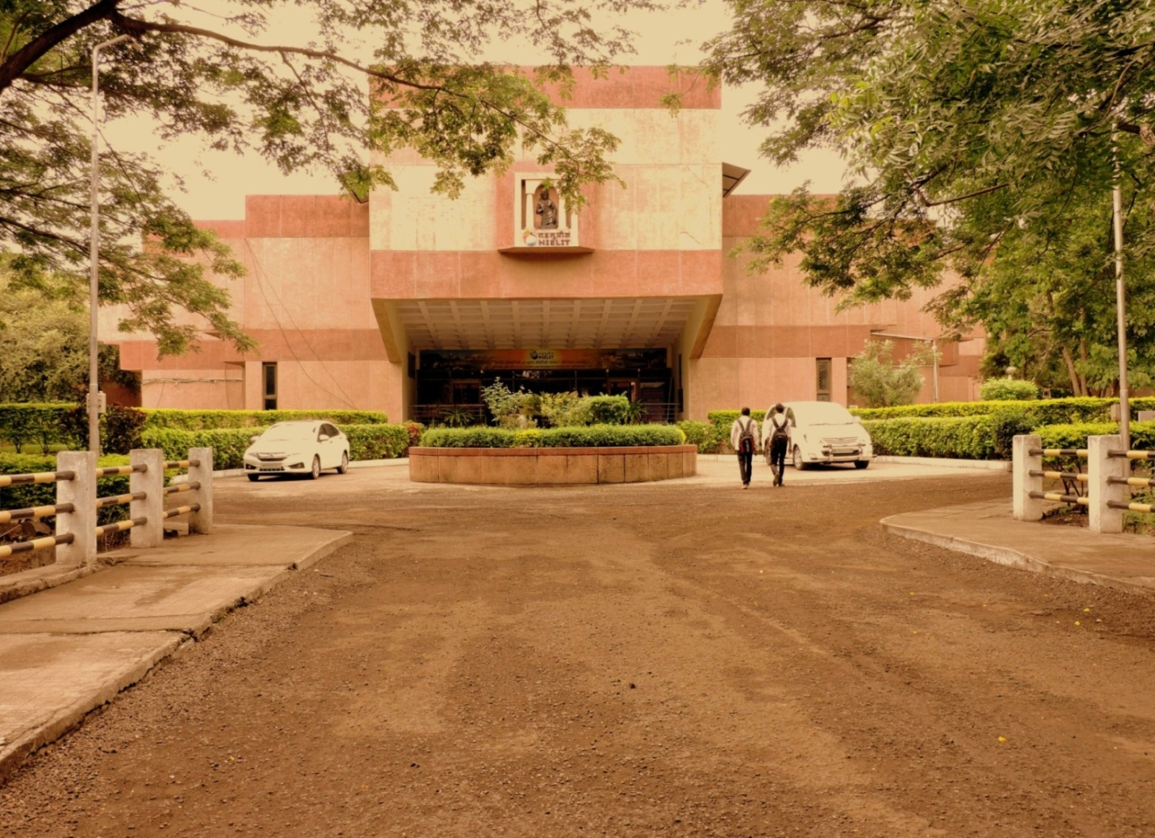

**EXECUTIVE DIRECTOR’S MESSAGE**

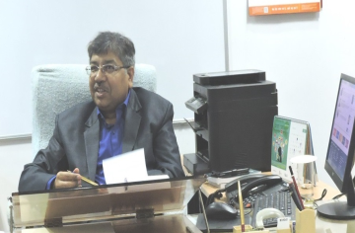

As the Executive Director of NIELIT Aurangabad Centre it gives me immense pleasure to share with you that this Centre is among the frontrunners and a leader in providing solution-oriented approach for promotion of Electronics and IT in the region. Located in the sprawling and lush green campus of the Dr. Babasaheb Ambedkar Marthwada University, the Centre is providing world-class educational and skill development opportunities to the youth through state-of-the-art teaching methodologies in both Formal and Non Formal sectors.

Established in 1986, the high-end courses provided by the Centre are aimed towards holistic development of students and the enviable success rate in term of employments boasts of many niche companies in both India and abroad. At NIELIT Aurangabad, we strongly believe that ‘Quality’ is not a destination, but a journey to improve. Thus, through a range of technical programs and courses that are aligned to the ‘Skill India’, ‘Make-In-India’ and the ‘Digital India’ initiatives of the Government of India, the Centre is endeavoring to lead by example in providing academic excellence and quality technical education to support the vision of the Hon’ble PM, Hon’ble Union Minister (E&IT) and Hon’ble Union MoS (E&IT) of a ‘सशक्त और समृद्ध भारत’.

Dr. Sanjeev Kumar Gupta Executive Director,

NIELIT Aurangabad

**ABOUT THE INSTITUTE AND THE COURSES**

The NIELIT Aurangabad Centre (formerly Centre for Electronics Design and Technology, (CEDT)), was established in the year 1986 jointly by Department of Electronics & Information Technology (DeitY), Ministry of Electronics & Information Technology (MoE&IT), Govt. of India, Govt. of Maharashtra and Dr. B.A.M. University, Aurangabad (Maharashtra). The institute is engaged in the area of manpower training, product design & development, applied research and consultancy in the field of Information, Electronics, and Communication Technology (IECT).

Centre offers affordable quality education in Formal and non-Formal Sector.The most sought after Formal Sector Courses that the Centre offers includes AICTEapproved courses namely Diploma in Electronics Production and Maintenance, B Tech (Electronics System Engineering) and M Tech (Electronics Design and Technology). Centre is also a Recognized Research Centre of the Dr. B.A.M. University, Aurangabad for conducting research leading to Ph.D. Degree in Engineering and Technology.

**INFRASTUCTURE**

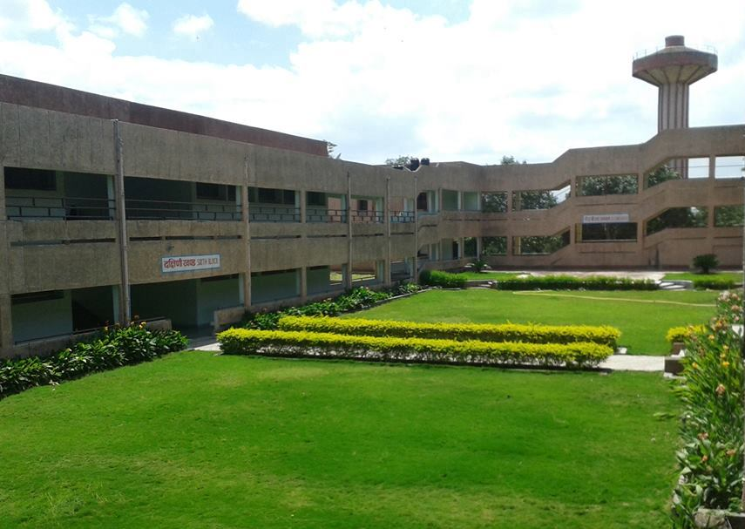The campus has a beautifully landscaped building with 12,200 Sq. meters built-up area, situated on 18.65 acres of hillside land in the university campus and features landscaping with well-maintained lush green lawns creating an ideal learning environment to stimulate intellectual and personal growth.

**CLASSROOMS:-**

State-of-the-art ‘Smart’ Classrooms with high-speed data networks and large projection systems for audio and video and discussion rooms enhance student learning. Local intranet of the centre implements a "virtual classroom," where all the visual material, such as presentation slides used by faculty in class, are made available electronically to students

**COMPUTING FACILITIES:-**

High-speed 24*7 Internet accessis availableto students throughout campus, in both wired and wireless modes.

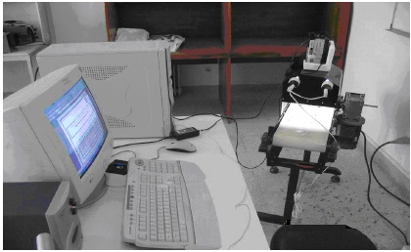The Internet connectivity to the campus throughone GBPS Leased Line connection from BSNL (NKN) is augmented with a leased line from aprivate ISP.

**RESEARCH FACILITY**:-

At present more than 90 PhD Scholars students are pursuing research at our centre.

Institute has a Startup centre for creation of socially-relevant solutions and tofacilitate adoption of "Technology for Public Good". Institute also houses aninnovation Center to support and incubate new ventures and to promote commercialization of IP generated by faculty and students

**LAB FACILITIES:-**

1. PCB lab- Here students design & fabricate the PCB of their Product using PCB design software(CADSTAR), PCB fabrication & Assembly Setup & SMD facility
2. Product design Lab is used for Product Development &is equipped with 3D Printer, 3D Scanner & High end CAD workstations and Tools like CATIA V5, CREO (Pro/Engineer), Master CAM, CNC Machine Tools, ,
3. 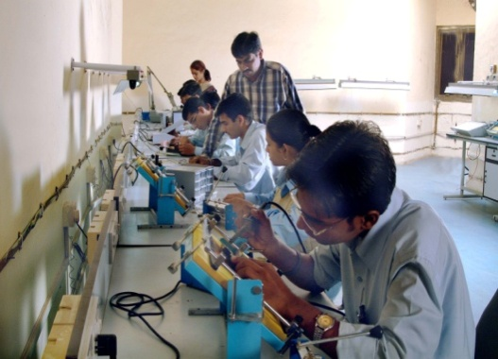Embedded Systems Lab is equipped with Arduino, Raspberry Pi, Beagle bone controller boards ,Microprocessor & DSP Kits- AVR ,ARM , OMAP etc
4. VLSI Lab is equipped with Synopsys EDA Tool, Xilinx tools- ISE, Vivado ,Altera tools-Quatus, Nios etc
5. Industrial Automation Lab is equipped with  National Instruments Multisim, LabVIEW, Data Acquisition Systems, NI Compact RIO, TIA Portal for SCADA & PLC, MATLAB, ELVIS Board etc
6. Optoelectronics Lab hasfacilities like OTDR, Optical power meter, N/W Analyzer, High speed digital links Fusion splicing machine, fiber amplifier, Trainer Kits from Newport Corporation etc.
7. Test & Measurement Lab has Higher end Test equipments like 100Mz Digital Storage Oscilloscope, 500 Mz Mixed Signal Oscilloscope , Mixed Domain Oscilloscope, spectrum analyzer, Thermal Camera etc.

**LIBRARY:-**

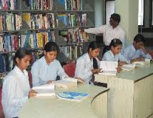The Library of the NIELIT Aurangabad is continuously growing with qualitative documents i.e. books, journals, digital documents, magazines and dailies on Science, Technology, Engineering, Economics, Management, Professional Communication, Ethics and other subjects. Library has e-subscriptions to ASTM Digital Library, Elsevier Sciencedirect Digital Library, and IEEE Xplore Digital Library toprovide access to e-journals

**HOSTEL FACILITIES:-**

The Institute campus houses three hostels for boysand one hostel for girlsis in Dr BAMU UniversityGirls Hostel premises. Medical & Canteen facilities in the campus make life at NIELIT comfortable.

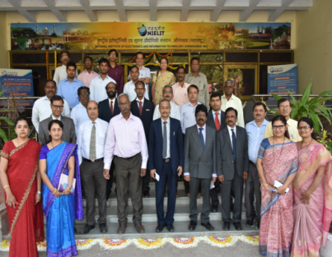**FACULTY:-**

The aim of the institute is to provide highly talented and proficient faculty to the students who share a common goal to put NIELIT, Aurangabad on the International map as a technology hub. Currently there are more than thirty faculty members who initiate research activities in various disciplines. With the right mix of experience and youth they have great enthusiasm to motivate the students towards learning & innovation which helps them to foster and shape their career.

**TRAINING AND PLACEMENTS**

Industrial training and internshipbeing an integral part of curriculum at NIELIT Aurangabadgivesstudentsan opportunity experience the industrial environment before they graduate to enhance their technical, interpersonal, managerial and leadership skills.

The MODEL CAREER CENTRE housed in NIELIT Aurangabad under Ministry of Labour & Employment (MoLE), Govt. Of India facilitates internships for students in industries, corporate, academia, NGO and other organizations of National and International repute.

**PLACEMENT SUPPORT:-**

In order to provide an impetus to NIELIT qualifiers, efforts are being made to facilitate and empower these qualifiers by way of a dedicated placement portal. We also encourage students to organize events such as Conscendo (Inter- College Management Festival) and encourage their involvement in activities of social relevance through NSS Cell of the institute.

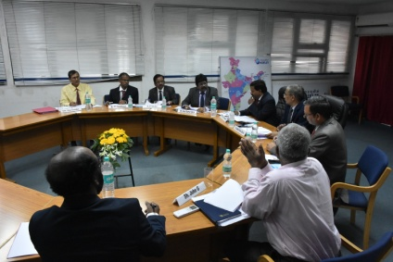**INDUSTRIAL COLLABORATION:-**

NIELITAurangabad provides consultancy and other services to Industries like Bajaj Auto Ltd, Videocon, Sterlite, Siemens, Maharashtra Police Wireless etc.

**ALUMNI CLUB:-**

NIELIT AurangabadAlumni are holding influential positions in reputed organizations like HCL, Infosys, Wipro, Intel, Tata communication,Capgemini, Accenture etc.Some of them have foundedcompanies are successful entrepreneurs. Our Alumni being engaged with the Institute and are playing major role in its growth.

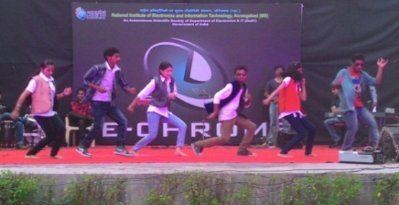**CAMPUS LIFE@ NIELIT, AURANGABAD**

**TECHNICAL FEST:-**

To enhance student’s confidence, leadership qualities, and attitude, management, communication and creative skills, every year NIELIT Aurangabad organizes Annual Technical festival "ELE-CHROME" which is attended by students from all over Maharashtra.

**CLUBS-ART & CULTURE: -**

Various clubs give students autonomy&opportunity to exercise their techno-managerial, artistic & creative skillsin a responsible manner. Hailing from diverse social and cultural backgrounds, they manage various clubs, events and festivals, which buildtheir ability to work in teams, endow them with leadership qualities to make them all-rounder

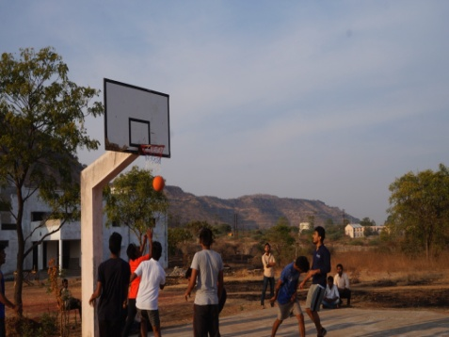

**SPORTS & GAMES**:

NIELIT Aurangabad hasthe requisiteinfrastructure for various recreationaland sports activities. Be it formal participation in sportsor activities such as trekking and gaming, one can always find something to match one’s interests.

**GYMNASIUM:-**

Students of NIELIT Aurangabad enjoy gym facility under the supervision of a certified trainer.

For **M.Tech (EDT)]Part Time Course Prospectus** Click [here](M.Tech%20(EDT)%20Part%20Time%20Course%201.docx)

For **M.Tech (EDT)]Full  Time Course Prospectus** Click [here](M.Tech%20(EDT)%20Full%20%20Time%20Course%201.docx)