NIELIT J&K launches "Future Skill Orientation & Mentorship Program"
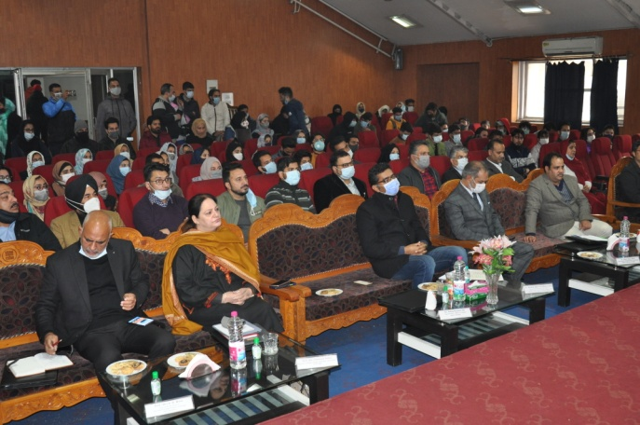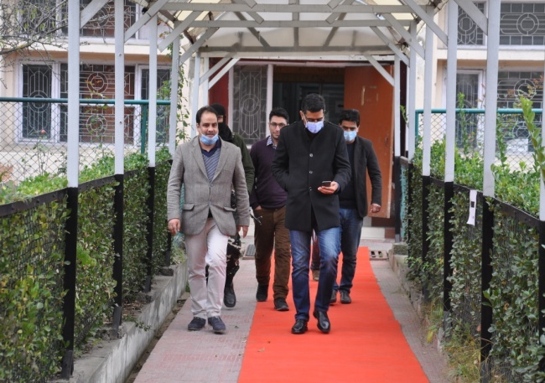

In one of its kind initiative, NIELIT J&K launched "Future Skill Orientation & Mentorship Program" on 05th Nov 2021at NIELIT Srinagar will provide an ecosystem for the students to get industry exposure. The function was graced by , Dr. Shahid Iqbal Choudhary (IAS), Administrative Secretary, Tribal Affairs (Addl. Charge of Chief Executive Officer, Mission Youth & Mission Director, Skill Development Mission) at NIELIT Srinagar campus Prof. (Dr.) Yasmeen Ashai, Director Colleges, Deptt. Of Higher Education, UT of J&K and Prof. (Dr.) A. H. Moon, Dean Academic Affairs & Dean School of Engineering & Technology IUST, Awantipora were the guest of honour. Dr. Shah Jahan Wani Dean, Faculty of Engineering & Technology, Cluster University, Srinagar, Sh. Gurmeet Singh, Executive Director, Electronics & Computer Software Export Promotion Council (ESC) India, Yasir Kazmi, CEO, Myasa Networks Solution, Sameer Ahsan, CEO, Infinity Access Group along with the staff and students of NIELIT Srinagar/Jammu also graced the occasion.
Dr. Shahid Iqbal Choudhary appreciated the efforts of NIELT J & K in the skill development of the students within the U.T of J & K . He emphasized that the quality of the skill needs to be improved and highlighted that the right kind of skilling must be undertaken to enrich the talent pool in the U.T of J & K . He further added that the initiative undertaken by NIELIT will help to prepare and groom students for industry needs thus enhancing their employability opportunities.
All the speakers from the industry, academia and the J&K Govt vowed to work in tandem to achieve the common objective of Skilling/Up-skilling for the youth of J&K so that they are industry ready and highly employable.

